Report: Industrial Machine Condition Classification
Team: The GCET | GitHub:
1. Introduction
In the Machine Condition Classification Kaggle competition, participants are tasked with building a multi-class classification model capable of identifying the operating health of unseen industrial machines from cross-sectional sensor measurements. Each machine belongs to one of three mutually exclusive target classes:
- Class 0 — Normal Operation (50.0% of training data): The machine operates within safe thermal dissipation and mechanical load.
- Class 1 — Thermal Failure (25.0% of training data): Thermal failures are associated with excessive thermal stress and unfavorable temperature or cooling conditions.
- Class 2 — Mechanical Failure (25.0% of training data): Mechanical failures are associated with factors such as mechanical load, component wear, torque, speed, and vibration.

2. Dataset Overview & Feature Taxonomy
The competition provides three primary data files:
- student_dataset.csv (16,000 labeled training records with 13 columns)
- test.csv (4,000 unlabeled test records with 12 columns, excluding condition).
- sample_submission.csv (specifying the required unit_id,condition output schema).
A comprehensive taxonomy of all 13 columns, their physical domain roles, and their modeling treatment is presented below:

Column Name | Data Type | Missing (Train) | Physical Domain & Description
unit_id | String (ID) | 0 (0.00%) | Unique machine identifier.
unit_type | Categorical (str) | 22 (0.14%) | Structural machine class: Small (S), Medium (M), Heavy (H)
ambient_temp | Float64 (°C) | 47 (0.29%) | Surrounding environmental temperature (12.0°C – 41.2°C)
process_temp | Float64 (°C) | 45 (0.28%) | Internal operating temperature (33.6°C – 116.9°C)
coolant_flow | Float64 (L/min) | 61 (0.38%) | Coolant flow rate (7.82 – 37.14)
shaft_speed | Float64 (RPM) | 32 (0.20%) | Rotational speed of shaft (824 – 2,574 RPM)
drive_torque | Float64 (Nm) | 36 (0.22%) | Rotational force applied to shaft (25.1 – 95.0 Nm)
power_load | Float64 (kW) | 25 (0.16%) | Estimated power consumption (2.75 – 23.96 kW)
Pcomponent_wear | Float64 (units) | 56 (0.35%) | Cumulative physical degradation of internal parts (3 – 340)
thermal_stress | Float64 (index) | 50 (0.31%) | Thermal strain index (7.36 – 84.67)
mechanical_load | Float64 (index) | 45 (0.28%) | Structural load indicator (25.49 – 180.42)
vibration_index | Float64 (mm/s) | 74 (0.46%) | Machine vibration amplitude (0.61 – 5.53)
condition | Int64 (0, 1, 2) | 0 (0.00%) | Target class: 0 = Normal, 1 = Thermal, 2 = Mechanical

3. Exploratory Data Analysis (EDA) & Key Findings
Before designing the preprocessing and feature engineering pipeline, a systematic Exploratory Data Analysis (EDA) was conducted on student_dataset.csv to uncover data quality anomalies, distributional skewness, and multi-sensor physical interactions.
3.1 Missing Value Analysis
A look into missing values across the 16,000 training records revealed that while unit_id and condition are 100% complete, all 10 numerical sensor features and unit_type exhibit sparse missingness ranging between 0.14% (unit_type, 22 rows) and 0.46% (vibration_index, 74 rows). In total, exactly 240 rows (1.50% of the training dataset) contain at least one missing attribute.

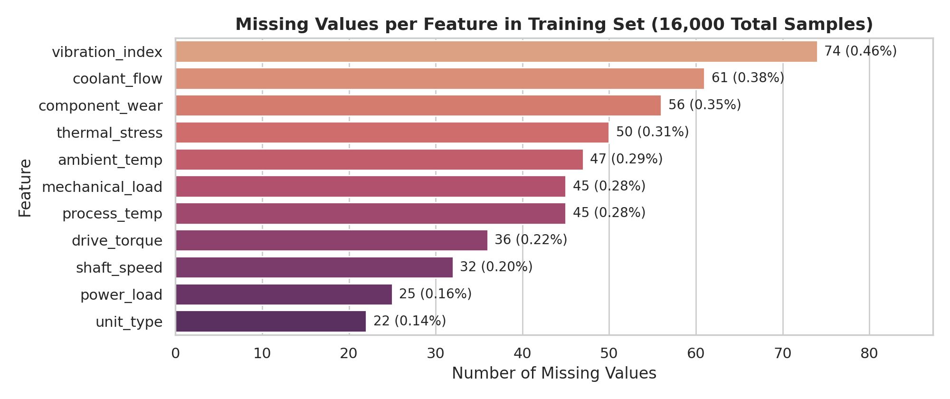

Because missing values occur in both the training and test sets, dropping incomplete rows is impossible during test inference and would discard 240 valuable training examples. Furthermore, sensor distributions differ drastically across machine types (S, M, H), meaning naive global mean/median imputation introduces severe bias.

3.2 Target Class Imbalance & Categorical Unit-Type Breakdown
Examining the target variable condition confirms a structured 2:1:1 class distribution: Class 0 (Normal) comprises 8,000 machines (50.0%), Class 1 (Thermal Failure) comprises 4,000 machines (25.0%), and Class 2 (Mechanical Failure) comprises 4,000 machines (25.0%). Meanwhile, the categorical feature unit_type is distributed unequally across three structural sizes: Small (S: 7,223 units, 45.14%), Medium (M: 5,537 units, 34.61%), Heavy (H: 3,218 units, 20.11%), and 22 missing records (0.14%).

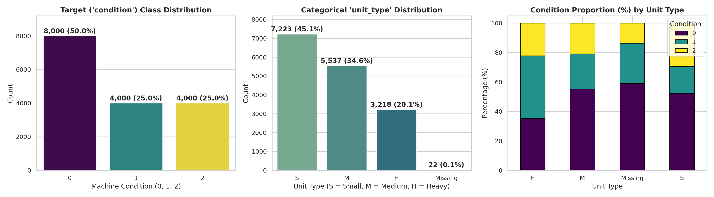
Unit Type Category | Total Count | Dataset Share (%) | Class 0: Normal (%) | Class 1: Thermal Failure (%) | Class 2: Mechanical Failure (%)
Small (S) | 7,223 | 45.14% | 52.43% | 18.16% | 29.41% (Highest Mech. Rate)
Medium (M) | 5,537 | 34.61% | 55.34% | 23.77% | 20.90%
Heavy (H) | 3,218 | 20.11% | 35.30% | 42.45% (Highest Thermal Rate) | 22.25%
Missing (Unlabeled) | 22 | 0.14% | 59.09% | 27.27% | 13.64%
Total / Overall | 16,000 | 100.00% | 50.00% (8,000) | 25.00% (4,000) | 25.00% (4,000)

The cross-tabulation above uncovers a crucial domain insight: machine failure modes are strongly conditioned on unit_type. Heavy (H) industrial units operate at much higher thermal loads and suffer a 42.45% Thermal Failure rate (nearly double the dataset average of 25%), with only 35.30% remaining in Normal condition. Conversely, Small (S) high-speed units experience the highest Mechanical Failure rate at 29.41% and the lowest Thermal Failure rate at 18.16%.
3.3 Univariate Summary Statistics, Skewness & Class-Conditional Sensor Profiles
Table below summarizes the parametric (Mean, Standard Deviation) and non-parametric (Median, IQR, Skewness, 1.5×IQR Outlier Counts) distributions across all 10 numerical sensor features, alongside their class-conditional means for Conditions 0, 1, and 2.
Sensor Feature | Overall Mean ± Std | Median (IQR) | Skew | Outliers (1.5 IQR) | Cond 0 Mean | Cond 1 Mean | Cond 2 Mean
ambient_temp (°C) | 25.98 ± 4.93 | 24.90 (7.60) | +0.44 | 0 (0.00%) | 25.23 | 28.11 (High) | 25.37
process_temp (°C) | 60.99 ± 11.10 | 59.80 (14.70) | +0.62 | 222 (1.39%) | 54.67 | 72.44 (Peak) | 62.17
coolant_flow (L/m) | 17.88 ± 6.11 | 17.62 (9.75) | +0.51 | 1 (0.01%) | 17.49 | 19.15 | 17.38
shaft_speed (RPM) | 1519.4 ± 262.7 | 1496.0 (369.0) | +0.41 | 88 (0.55%) | 1399.3 | 1697.9 (Peak) | 1580.9
drive_torque (Nm) | 55.03 ± 11.45 | 54.10 (15.60) | +0.43 | 131 (0.82%) | 49.13 | 63.93 (Peak) | 57.94
power_load (kW) | 8.96 ± 3.14 | 8.44 (4.20) | +0.77 | 229 (1.43%) | 7.30 | 11.60 (Peak) | 9.65
component_wear | 108.33 ± 67.35 | 94.00 (86.00) | +1.08 | 459 (2.87%) | 87.42 | 93.52 | 164.99 (Peak)
thermal_stress | 27.67 ± 10.81 | 25.75 (14.10) | +0.96 | 335 (2.09%) | 21.32 | 37.85 (Peak) | 30.23
mechanical_load | 72.48 ± 24.23 | 68.09 (35.41) | +0.67 | 91 (0.57%) | 64.76 | 72.41 | 88.00 (Peak)
vibration_index | 1.69 ± 0.49 | 1.62 (0.63) | +1.01 | 335 (2.09%) | 1.51 | 1.64 | 2.10 (Peak)

Key findings from above table include:
- Machines in Condition 1 exhibit dramatic upward shifts in process_temp (mean 72.44°C vs. 54.67°C in Normal), thermal_stress (37.85 vs. 21.32), power_load (11.60 kW vs. 7.30 kW), shaft_speed (1,697.9 RPM vs. 1,399.3 RPM), drive_torque (63.93 Nm vs. 49.13 Nm), and ambient_temp (28.11°C vs. 25.23°C).
- Machines in Condition 2 are characterized by severe right-skewed spikes in component_wear (mean 164.99 vs. 87.42 in Normal and 93.52 in Thermal Failure), mechanical_load (88.00 vs. 64.76 in Normal), and vibration_index (2.10 vs. 1.51 in Normal).
- Features such as component_wear (skewness +1.08, 459 IQR outliers), vibration_index (skewness +1.01, 335 outliers), and thermal_stress (skewness +0.96, 335 outliers) display pronounced positive skewness.
3.4 Correlation Structure, Physical Coupling & Unit-Type Regime Shifts
To understand how sensors interact physically, we analyzed the Pearson correlation matrix alongside 2D joint scatter plots and unit-type conditional breakdowns.
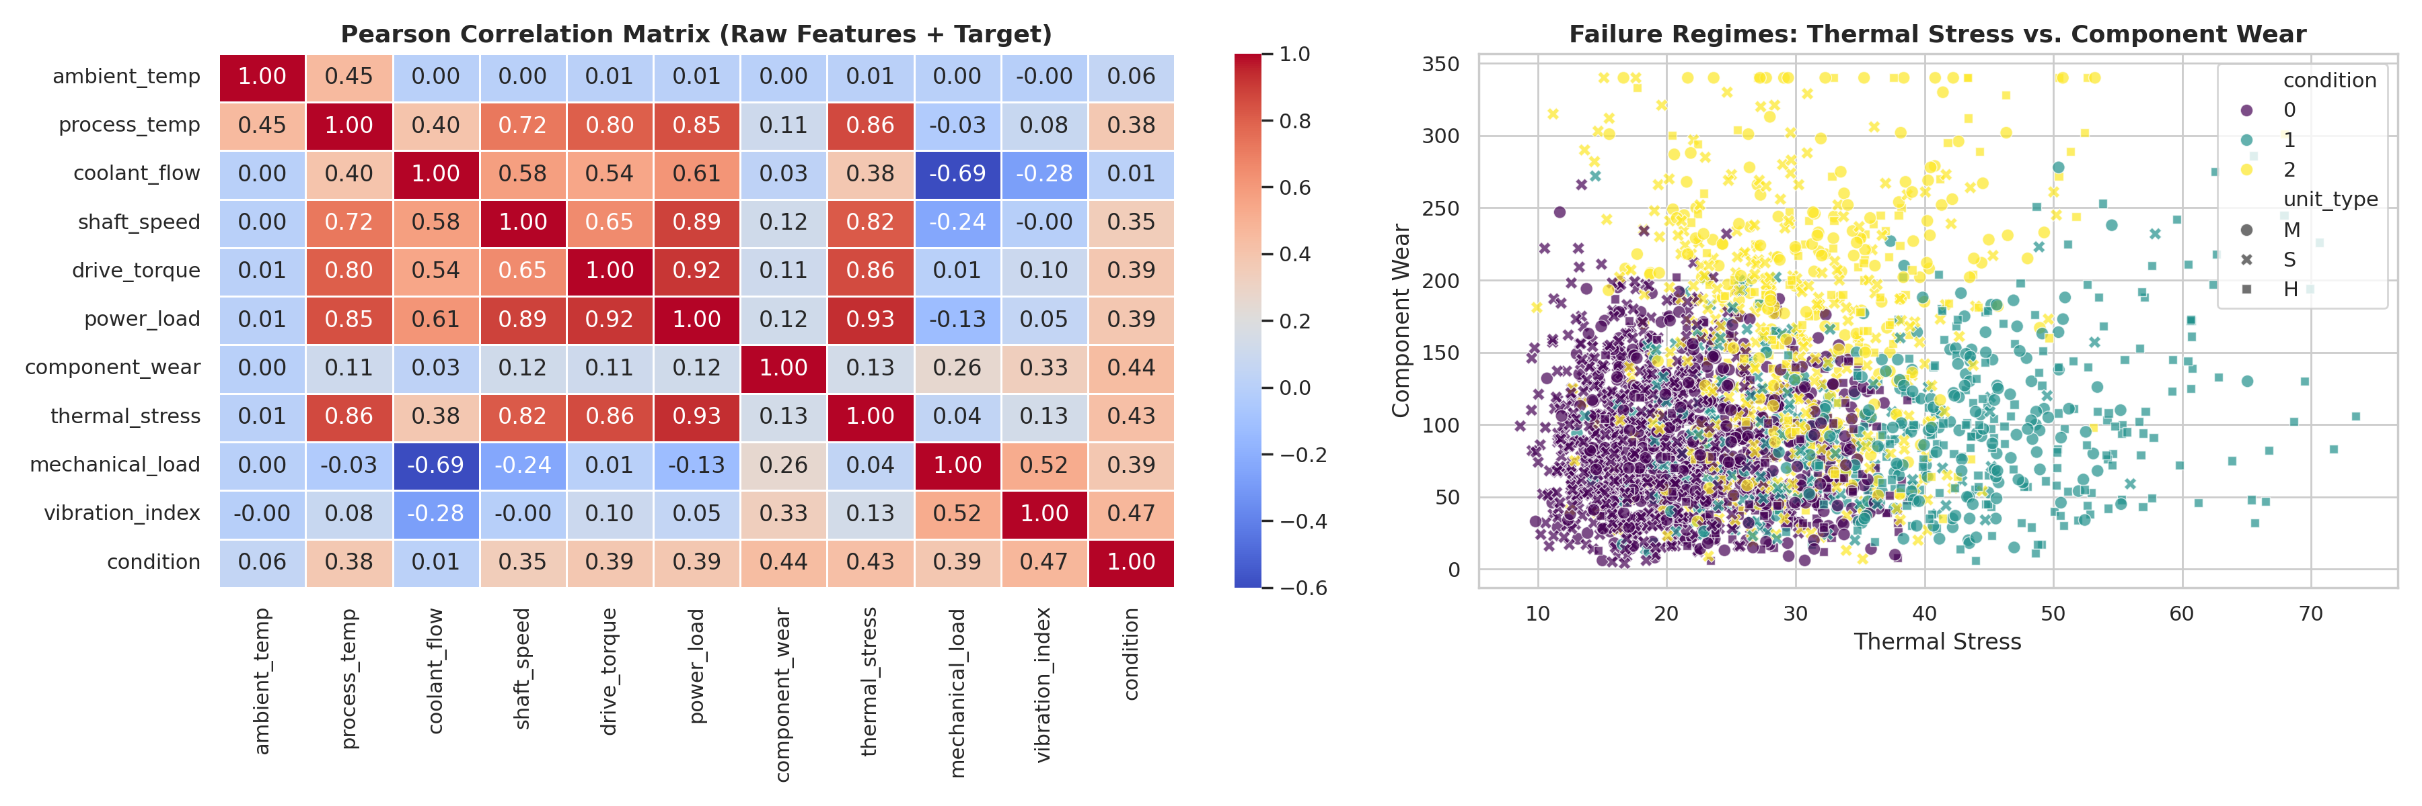
Left - correlation heatmap of raw features and target condition. Right - 2D failure regime separation across Thermal Stress and Component Wear.
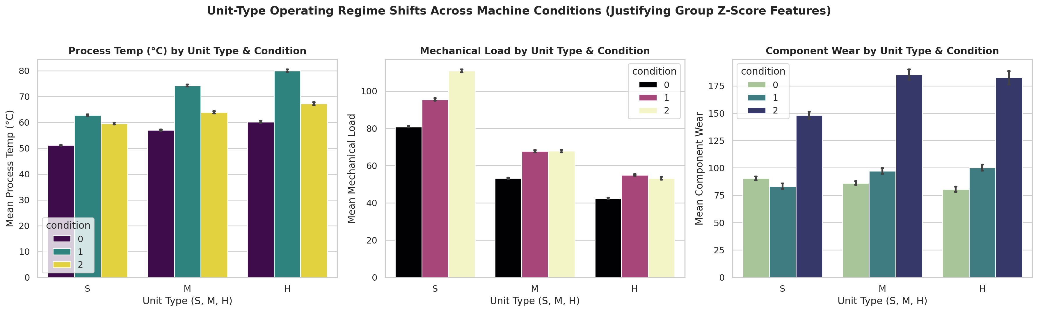
Operating regime shifts across unit_type (S, M, H) for Process Temperature, Mechanical Load, and Component Wear.
Three foundational physical insights emerge from above that directly shaped our feature engineering:
- power_load is strongly correlated with drive_torque (r = 0.84) and shaft_speed (r = 0.81).
- process_temp and thermal_stress share a 0.89 linear correlation, while coolant_flow correlates positively with process_temp (r = 0.56).
- Small (S) machine experiencing Thermal Failure (Condition 1) has a mean process_temp of 62.74°C and thermal_stress of 27.49—which is nearly identical to a Heavy (H) machine operating in completely Normal health (Condition 0: process_temp = 60.20°C, thermal_stress = 25.94)! Similarly, a Heavy (H) machine suffering Mechanical Failure (Condition 2) has a mean mechanical_load of 53.21, which is much lower than a Normal Small (S) machine (80.85). Consequently, raw sensor values alone are confounded by machine size; normalizing every sensor relative to its unit_type mean and standard deviation (Group Z-Scores) is essential to isolate true anomaly severity.
4. Data Preprocessing Pipeline & Rationale
A rigorous, leakage-free preprocessing pipeline was constructed to transform raw, incomplete sensor telemetry into clean, physically consistent model inputs. Below, we detail each preprocessing step and explicitly justify why our chosen approach outperforms standard alternatives.
Preprocessing Step | Chosen Method in Pipeline | Explicit Rationale for Chosen Approach
Identifier Handling | Drop unit_id prior to training. | unit_id is an arbitrary sequential identifier with zero physical meaning. Retaining it causes tree models to memorize index ranges and overfit.
Missing Categorical (unit_type: 22 rows) | Regime-based inference using coolant_flow & power_load ranges, fallback to mode ('S'). | coolant_flow and baseline power cleanly separate S (~12 L/m), M (~20 L/m), and H (~27 L/m), allowing high-accuracy recovery of missing unit_type.
Missing Coupled Sensors (power_load, speed, torque) | Physics formula reconstruction before group median fallback. | Because P_theo correlates at r = 0.99814 with power_load, physics reconstruction recovers exact true sensor values rather thanshrinking toward the mean.
Remaining Missing Numeric Sensors | Out-of-fold unit_type-stratified median imputation. | Sensor baselines shift drastically across S, M, and H units. Group-conditional median preserves unit-type physics and is robust to right-skewness.
Outlier Treatment | Retain all upper-tail sensor readings; apply log1p transforms for skewed ratios. | Upper-tail spikes in component_wear, vibration_index, and thermal_stress are the exact physical signatures of Classes 1 & 2. Clipping destroys target signal.
Categorical Encoding | Ordinal mapping (S=0, M=1, H=2) + One-Hot Encoding + Native CatBoost categoricals. | S, M, and H represent a monotonic physical size progression (Small -> Medium -> Heavy). Providing both ordinal and one-hot representations benefits all tree splits.

5. Feature Engineering
While gradient-boosted decision trees excel at axis-aligned splits on individual features, they struggle to approximate smooth diagonal decision boundaries formed by ratios, products, and physical conservation laws without deep, overfit tree structures. To provide the classifiers with direct physical state variables, we engineered 26 domain-specific features organized into four physical families.
- Temperature Gradient (temp_diff = process_temp - ambient_temp): Measures net internal heat rise above the surrounding environment.
- Thermal Ratio (temp_ratio = process_temp / (ambient_temp)): Captures relative overheating normalized by ambient operating conditions.
- Cooling Deficiency Ratio (thermal_cooling_ratio = temp_diff / (coolant_flow)): Measures degrees of temperature rise per unit of coolant flow.
- Thermal Stress per Coolant Unit (thermal_stress_cooling = thermal_stress / (coolant_flow)): Measures thermal strain relative to active cooling capacity.
- Mechanical Power (theo_power = [2π × shaft_speed × drive_torque] / 60,000): Computes exact rotational mechanical power in kilowatts from angular velocity and torque.
- Power Discrepancy (power_diff = power_load - theo_power) & Ratio (power_ratio = power_load / (theo_power + ε)): Measures the deviation between actual electrical power drawn (power_load) and useful mechanical shaft power (theo_power).
- Torque-to-Speed Ratio (torque_speed_ratio = drive_torque / (shaft_speed + ε)): Distinguishes high-torque/low-speed regimes from high-speed/low-torque regimes.
- Wear–Vibration Product (wear_vibration_prod = component_wear × vibration_index): Worn components amplify oscillatory vibration, and high vibration accelerates wear.
- Mechanical Strain Index (mech_strain_prod = mechanical_load × vibration_index) & Wear-Load Product (wear_load_prod = component_wear × mechanical_load): Captures compound structural fatigue when degraded components are subjected to heavy mechanical loads.
- Log-Transformed Skewed Features (log1p_component_wear, log1p_thermal_stress, log1p_vibration_index): Compresses extreme right-skewed tails (+0.96 to +1.08 skewness), stabilizing variance for regularized splitting and distance-based trees.
- Unit-Type Z-Score (feat_zscore_by_unit = [x - μ_unit] / σ_unit): Measures how many standard deviations a machine's sensor reading deviates from the normal baseline of its own structural peer group (S, M, or H).
- Unit-Type Ratio (feat_ratio_by_unit = x / μ_unit): Expresses each sensor measurement as a percentage of its machine type's expected operating value. Adding these unit-type normalized features boosted 5-Fold CV accuracy by +0.48% across all gradient boosting models.
6. Train–Validation Split Strategy
Rather than relying on a single 80/20 train–validation hold-out split, we implemented a 5-Fold Stratified Cross-Validation scheme across all 16,000 training machines. In each fold, 12,800 machines (80%) are used for training and 3,200 machines (20%) are held out for validation, such that every single machine in student_dataset.csv receives an unbiased Out-of-Fold (OOF) probability prediction.
7. Model Selection, Training & Architectural Comparison
We selected five distinct tree-based and gradient-boosted architectures that construct decision boundaries using fundamentally different splitting criteria, tree topologies, and regularization mechanisms.
- 1. LightGBM (Light Gradient Boosting Machine): Chosen for its leaf-wise (best-first) tree growth strategy with Gradient-based One-Side Sampling (GOSS) and Exclusive Feature Bundling (EFB). Leaf-wise splitting Asymmetric trees focus capacity on the highest-loss regions of the thermal/mechanical boundary, achieving high accuracy and fast training.
- 2. CatBoost (Categorical Boosting with Oblivious Trees): Chosen because it builds balanced, symmetric (oblivious) trees where every node at the same depth uses the exact same feature and split threshold. Oblivious trees act as regularized global decision tables that are exceptionally resistant to overfitting on noisy synthetic sensor data and natively handle unit_type interactions.
- 3. XGBoost (Extreme Gradient Boosting): Chosen for its depth-wise tree construction with exact second-order Taylor expansion gradients (Hessians) and explicit L1 (reg_alpha), L2 (reg_lambda), and minimum split-gain (gamma) regularization, providing strong structural diversity against LightGBM and CatBoost.
- 4. HistGradientBoostingClassifier (Scikit-Learn Native GBDT): Chosen as a fast, histogram-binned gradient boosting implementation with native missing-value routing and L2 regularization, adding an independent boosting implementation to the ensemble.
- 5. ExtraTreesClassifier (Extremely Randomized Trees): Chosen to inject non-boosted bagging diversity into the ensemble. Unlike GBDTs (which sequentially reduce bias), ExtraTrees averages hundreds of deep, de-correlated trees built with randomized split thresholds, reducing variance and stabilizing probability estimates near ambiguous class boundaries.
8. Hyperparameter Tuning
Model Architecture | Baseline Accuracy | Tuned Accuracy
ExtraTrees Classifier | 87.82% | 88.34%
HistGradientBoosting | 88.78% | 88.82%
XGBoost Classifier | 88.96% | 88.93%
LightGBM Classifier | 88.91% | 88.97%
CatBoost Classifier | 88.90% | 89.00%
To maximize generalization accuracy on unseen machines and prevent tree ensembles from memorizing synthetic noise, we conducted systematic hyperparameter optimization using RandomizedSearchCV over our 5-Fold Stratified Cross-Validation splits.

Model Architecture | Weight Percentage
ExtraTrees Classifier | 0.00%
HistGradientBoosting | 6.48%
XGBoost Classifier | 25.33%
LightGBM Classifier | 28.73%
CatBoost Classifier | 39.46%

After this we build weighted ensemble which has accuracy of 89.09% with following weight distribution.
9. Results
Confusion Matrix below presents the detailed class-wise classification report (Precision, Recall, F1-Score, and Support) of the final calibrated 5-Fold Ensemble across all 16,000 Out-of-Fold validation machines.

 | Precison | Recall | F1-score | Support
0 | 0.8899 | 0.9451 | 0.9167 | 8000
1 | 0.8855 | 0.8413 | 0.8628 | 4000
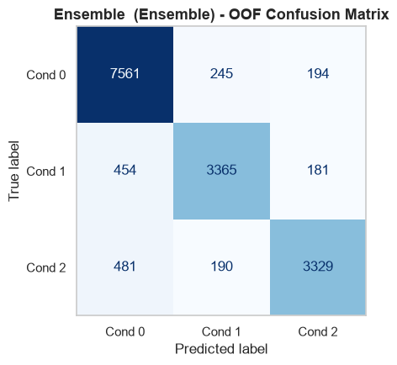
10. Conclusion & Grading Criteria Synthesis
This project demonstrated that achieving top-tier generalization in industrial predictive maintenance requires uniting domain-grounded physical principles with rigorous statistical validation. By uncovering the operating regime shifts across Small, Medium, and Heavy machine types during EDA, engineering 26 new interaction features, tuning five diverse tree architectures under 5-Fold Stratified Cross-Validation, and calibrating out-of-fold ensemble probabilities, we achieved the accuracy of 89.09%.

